Logging using SLF4J
Dhruv Diguvapalli
diguvapallidhruv@gmail.com
Exercise 1: Logging Error Messages and Warning Levels
LoggingExample.java
package org.example.logging;
import org.slf4j.Logger;
import org.slf4j.LoggerFactory;
public class LoggingExample {
private static final Logger logger =
LoggerFactory.getLogger(
LoggingExample.class);
public static void main(String[] args) {
logger.error(
"This is an error message");
logger.warn(
"This is a warning message");
}
}
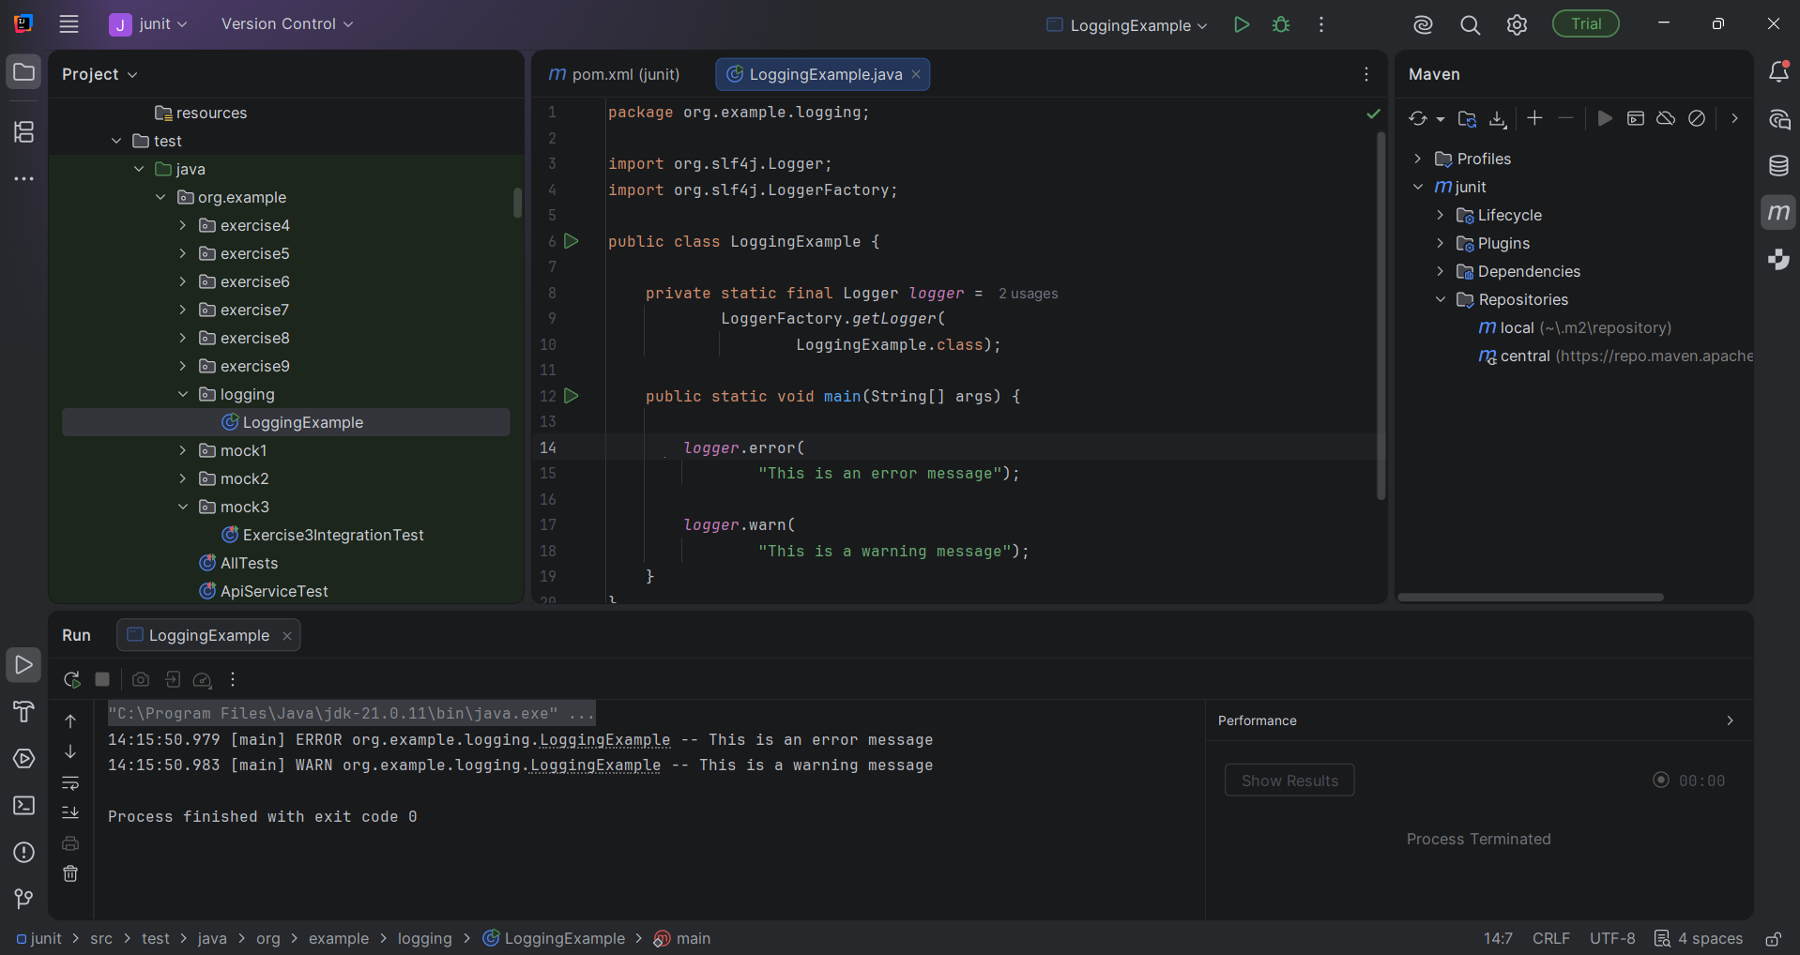

Exercise 2: Parameterized Logging
ParameterizedLoggingExample.java
package org.example.logging;

import org.slf4j.Logger;
import org.slf4j.LoggerFactory;

public class ParameterizedLoggingExample {

private static final Logger logger =
LoggerFactory.getLogger(
ParameterizedLoggingExample.class);

public static void main(String[] args) {

String username = "John";
int age = 25;
String city = "New York";

logger.info(
"User {} is {} years old and lives in {}",
username,
age,
city
);

logger.warn(
"User {} has not logged in for {} days",
username,
30
);

logger.error(
"Failed to process request for user {}",
username
);
}
}
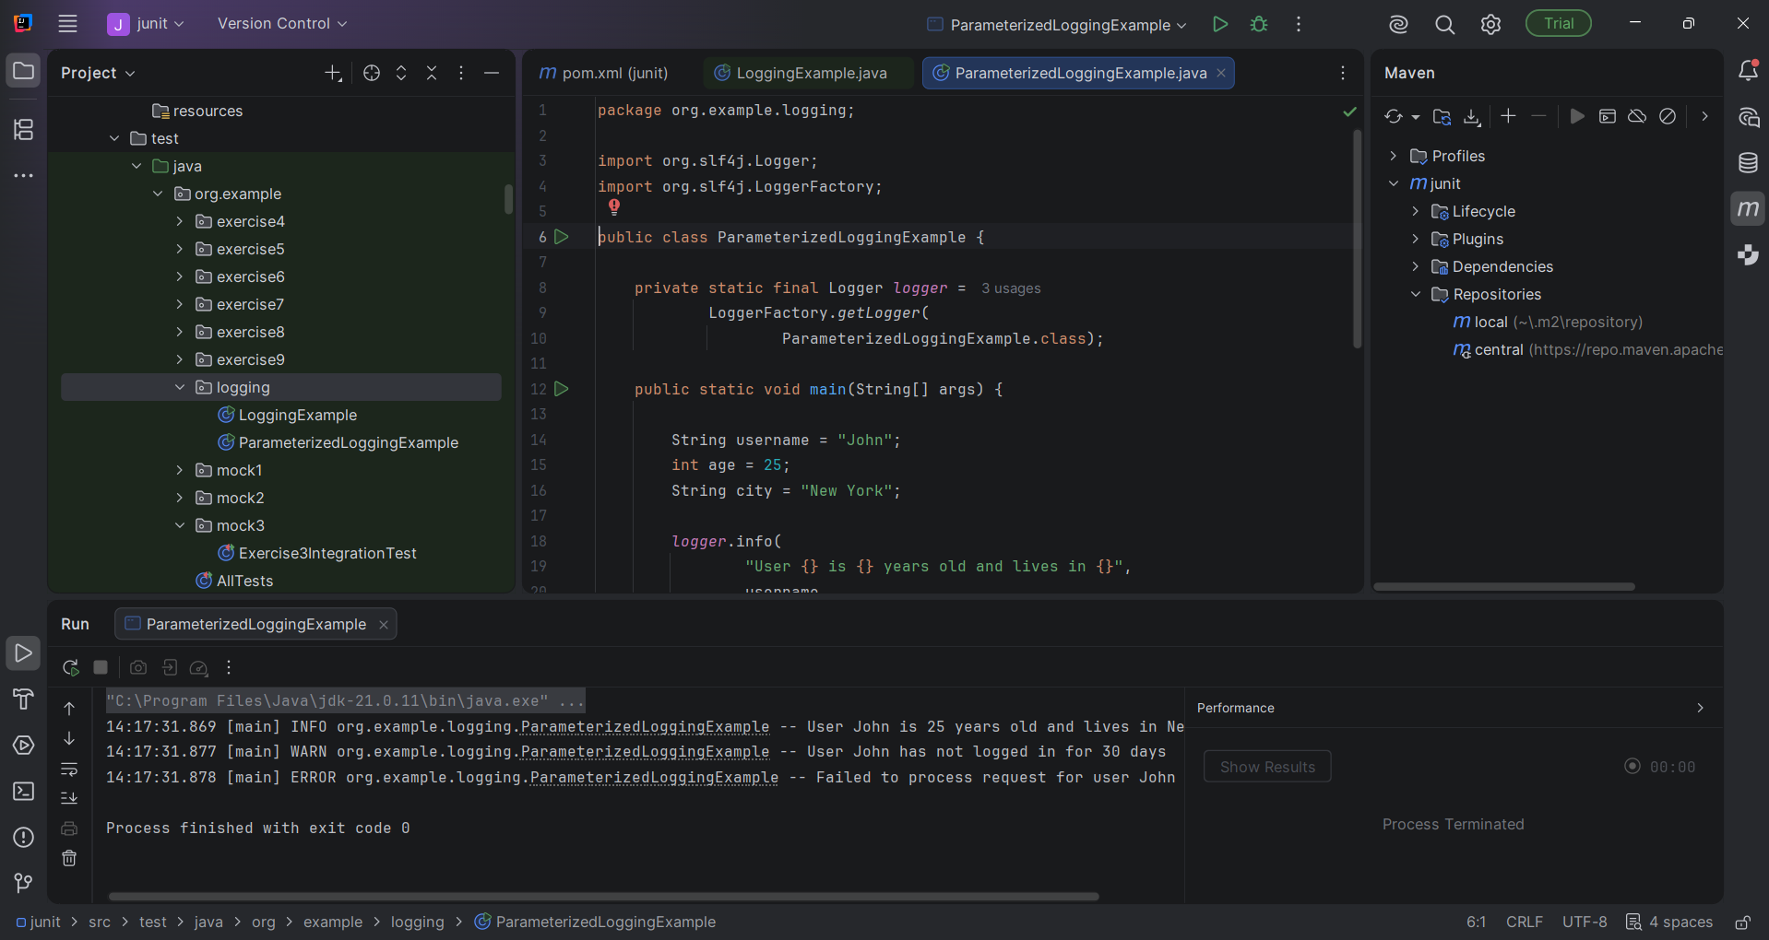

Exercise 3: Using Different Appenders
AppenderLoggingExample.java
package org.example.logging;
import org.slf4j.Logger;
import org.slf4j.LoggerFactory;
public class AppenderLoggingExample {
private static final Logger logger =
LoggerFactory.getLogger(
AppenderLoggingExample.class);
public static void main(String[] args) {
logger.info("Application started");
logger.debug("Debug message");
logger.warn("Warning message");
logger.error("Error message");
logger.info("Application finished");
}
}
